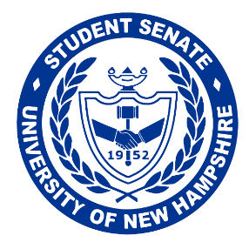
Student Senate of the University of New Hampshire

Academic Affairs Chair, Jennifer Hargenrader and Senators, Niko Dishaw and Bryce Gauthier submitted the following resolution for the consideration of the Student Senate:

Resolution
R.42.30 – On Academic Syllabi
28th of March, 2021

Whereas, only some faculty members include a detailed course timeline with assignment due dates on their syllabi, and

Whereas, including a detailed course timeline on syllabi would help students plan ahead for key assignments like exams and projects, and

Whereas, not all faculty members include information regarding required course texts in their syllabi, and

Whereas, including this information on syllabi would help students stay organized and allow them to be prepared for their courses, and

Whereas, many students must search for their syllabi in the modules tab on Canvas, which often contains countless documents unassociated with the syllabus itself, and

Whereas, consistently placing course syllabi in the appropriate “syllabus” tab on Canvas would be an easy way of making this search less tedious for students,

Therefore Be It Resolved By The Student Senate Of The University Of New Hampshire

To URGE, all faculty members to include a detailed course timeline on their syllabi for students to consult, and be it further resolved,

To URGE, all faculty members to include tentative dates for projects, assignments, and exams, and be it further resolved,

To URGE, all faculty to include information regarding required books or textbooks in their syllabi, including whether the required books or textbooks are available at the UNH Library or would need to be purchased from the bookstore, and be it further resolved,

To URGE, all faculty members to place their syllabi in the appropriate “syllabus” tab on canvas for students to easily access and distinguish from other documents.

Senate Action: Passes Unanimously
Speaker Verification: Igor Garcia

