APA 7th Edition
What is American Psychological Association (APA) style?
APA is a styled primarily used by the social sciences—psychology, sociology, nursing, family studies, etc.—and it places emphasis on the date of publication, whereas other styles (MLA, for example) emphasize the page number and edition used.

General Format
APA papers will use white 8.5x11 inch paper and margins will be 1 inch on all sides. Font must be legible, between 10 and 12 pt. size, and double spaced. Each page will have the page number in the upper right corner. Each paragraph will be indented one half inch on the left.

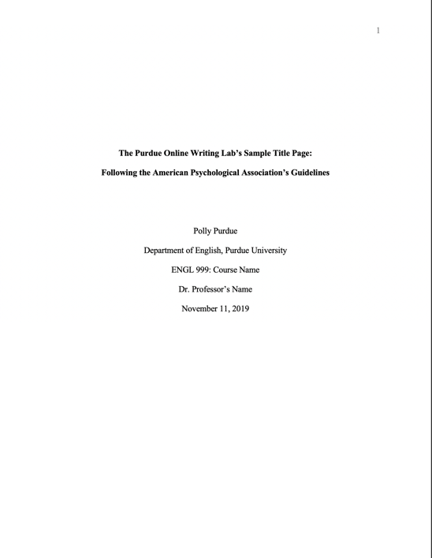
Title Page

The first page will be the title page and will include the following information:
- Title of your paper
- Your name
- Department
- Course number and name
- Instructor’s name
- Date

See the example to the left from OWL.Purdue.edu.

Abstract
The abstract appears on the second page. At the center of the top of the page, type “Abstract,” and one line under that will be a summary of your paper in 250 words or less, double spaced. Abstracts are not necessary for student papers.

In-text Citations
APA is a parenthetical documentation style, meaning the references appear within the sentences of the body of the essay like this: (Smith, 2000).
Two pieces of information must be included in the in-text citation:
- The first author’s last name
- The year of publication
When using direct quotes, also include the page number: (Smith, 2000, p. 200).
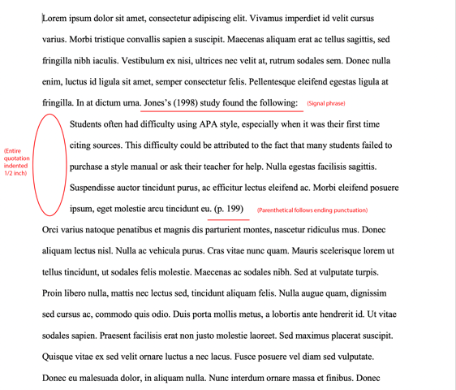
If the source is written by two authors, include both authors’ full name. If the source is written by three or more authors, you may replace the second and subsequent author names with “et al.”: (Smith, et al., 2000)

Text of 40 or more characters will utilize block quote format, which will indent the left margin an additional one half of an inch. There are no quotations with a block quote. See the example to the right from OWL.Purdue.edu.

Four ways to incorporate citations:
- At the end of the sentence: Researchers have pointed out that the lack of trained staff is a common barrier to providing adequate health education (Fisher, 1999) and services (Weist & Christodulu, 2000).
- Including a signal phrase with the author’s name: According to Fisher (1999), health education is required for high school graduation in Florida.
- Integrating the author and date into the sentence: In 2001, Weist proposed using the Child and Adolescent Planning Schema to analyze and develop community mental health programs for young people.
- Direct quotations: Lopez (1993) found that “the effect disappeared within minutes” (p. 311).

Reference List
- The word “References” will appear at the top of a new page. It will not be italicized, bolded, or underlined.
- Entries will be organized in alphabetical order by the author’s last name.
- All entries will be double spaced unless otherwise instructed.
- If an entry is longer than one line, a hanging indent will be used.
- Capitalize only the first word of titles of books or articles. If there is a subtitle, capitalize the first letter after the colon. Examples: Family mediation: Facts, myths, and future prospects or There’s more to self-esteem than whether it is high or low

Sample Reference Entries

Book with 1-2 authors
Author, A. A. (Year of publication). Title of work: Capital letter also for subtitle. Publisher Name.

Baxter, C. (1997). Race equality in health and education. Balliere Tindall.
Baxter, C. & Jones, W. (1997). Race equality in health and education. Balliere Tindall.

Organization as the author
Institution or organization name. (Year). Title of entry. In Title of reference work (edition, page numbers). Publisher name.

United States Government Accountability Office. (2019). Performance and accountability report: Fiscal year 2019. https://www.gao.gov/assets/710/702715.pdf

Chapter in an edited book
Author, A. A., & Author, B. B. (Year of publication). Title of chapter. In E. E. Editor & F. F. Editor (Eds.), Title of work: Capital letter also for subtitle (pp. pages of chapter). Publisher. DOI (if available)
Armstrong, D. (2019). Malory and character. In M. G. Leitch & C. J. Rushton (Eds.), A new companion to Malory (pp. 144-163). D. S. Brewer.

Journal article
Author, A. A., Author, B. B., & Author, C. C. (Year). Title of article. Title of Periodical, volume number(issue number), pages. DOI (if available)

Scruton, R. (1996). The eclipse of listening. The New Criterion, 15(3), 5–13.

Page on a website
Author, A. A. (Year, Month Date). Title of page. Site name. URL

Price, D. (2018, March 23). Laziness does not exist. Medium. https://humanparts.medium.com/laziness-does-not-exist-3af27e312d01

References
Purdue Online Writing Lab. (2022). APA style introduction. Purdue OWL. https://owl.purdue.edu/owl/research_and_citation/apa_style/apa_style_introduction.html

