Introducing the Raspberry Pi
The Raspberry Pi 3 Model B+ is the latest production Raspberry Pi 3 featuring a 64-bit quad core processor running at 1.4 Ghz. It incorporates built-in WiFi and Bluetooth connectivity with enhanced dual-band 2.4 GHz and 5 GHz WiFi, Bluetooth 4.2/BLE and faster Ethernet.

- 4 USB ports
- 40 GPIO pins
- Full HDMI port
- Ethernet port
- Combined 3.5mm audio jack and composite video
- Camera interface (CSI)
- Display interface (DSI)
- Micro SD card slot
- VideoCore IV 3D graphics core
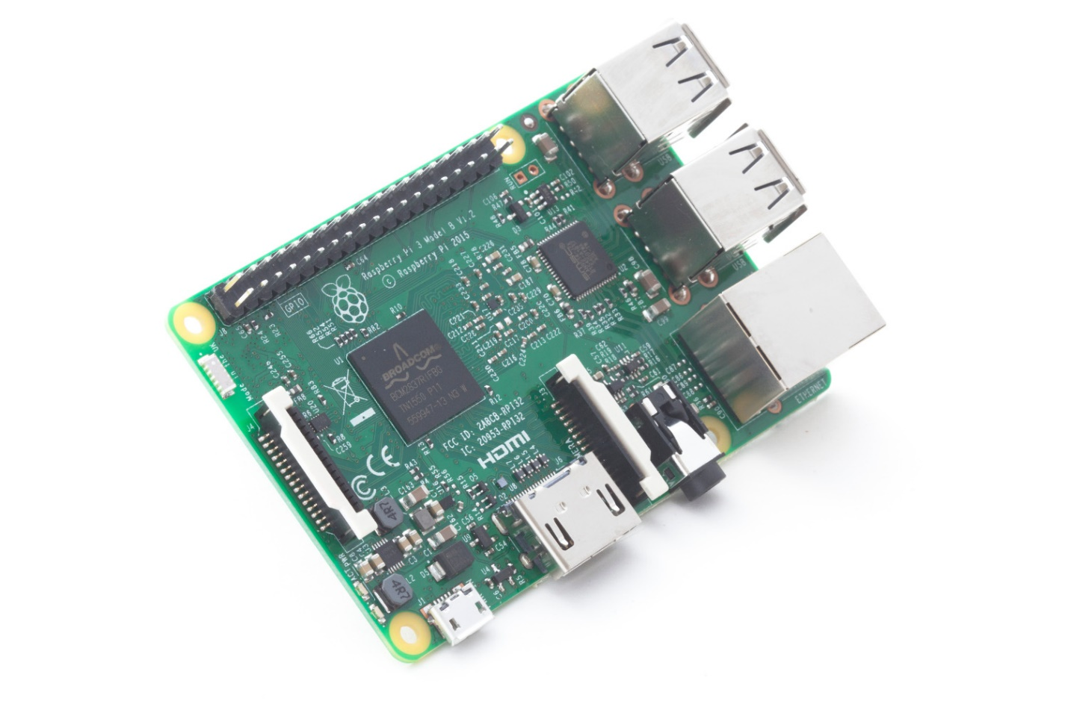
Software
- Python – computer programming
- GCC – C/C++ programming
- Java SDK – Java programming
- Code::Blocks – C/C++ programming environment
- BlueJ – Java development environment
- Geany – Java development environment
- GIMP – image processing (like Adobe Photoshop)
- Inkscape – vector graphics drawing program (like Adobe Illustrator)
- Fritzing – Electronic design
- MonoDevelop - .NET programming in C#
- Minecraft Pi Edition
- Scratch – Visual programming
- Mathematica – Symbolic Algebra System
- Libre Office – Office software
- TuxMath – Math drill program in form of a game
- TuxType – Typing tutor program
- TuxPaint – Paint program
- GCompris – Educational Software Suite
- GIMP – Image editor (like Photoshop)
- GBrainy – Brain teaser game
- Arduino IDE – Programming IDE for Arduino Microcontroller
- Processing – Integrated Development Environment built for the electronic arts
- VLC – Media Player
- Audacity – Multi-track audio editor

