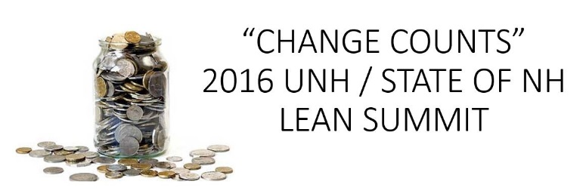
Operational Efficiency Award

Submission Form

Submittal Criteria: A UNH project that did not necessarily follow Lean methodology, however demonstrated process improvements between 1/1/2014 through present day.

How to submit:
- Complete the form below
- Email the completed form to Dagmar Vlahos at Dagmar.Vlahos@unh.edu on or before Friday, February 12, 2016
- Contact Dagmar if you have any questions at 862-4962 or via email
Submission due by February 12, 2016
Project Management Office will follow-up with you directly.
Your Name:
Project Name:
Describe the problem you were trying to solve:
Describe the changes made and the impact had:
Improvements Made | Provide quantitative estimates and/or qualitative descriptions.
- Cycle Time
- Cost Savings
- Customer Satisfaction
- Other
Project Team Lead:
Project Team Members:
Thank you for your submittal.

