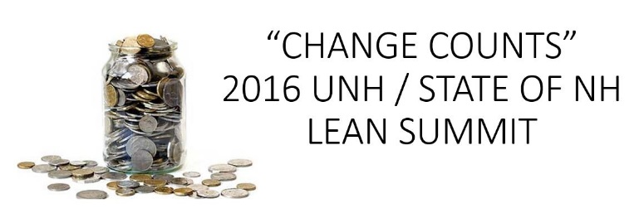

Lean Culture Award
Submission Form

Submittal Criteria: Be a UNH department. Participation in UNH Lean training.

How to submit:
- Complete the form below
- Email the completed form to Dagmar Vlahos at Dagmar.Vlahos@unh.edu on or before Friday, February 12, 2016
- Contact Dagmar if you have any questions at 862-4962 or via email
Submission due by February 12, 2016
Project Management Office will follow-up with you directly.
Your Name:
Name of nominated department:
Describe the adoption and use of Lean practices and process improvement within the department:
Lean Activity
% of employees trained  (Intro to Lean and/or Yellow Belt and/or Green Belt) | Introduction to Lean -  Yellow Belt –  Green Belt –  You are NOT required to have sent employees to all levels of training
# of Lean Projects completed or underway
Any additional information for consideration:

Thank you for your submittal.

