Banner 9 Student – Quick Reference Guide

- To access for UNH (PROD), go to my.unh.edu. Search for “Banner Student”. Click “Banner Student (Banner 9)”.
- To access for GSC (SLLP), go to my.unh.edu. Search for “Banner Student”. Click “Banner Student GSC (Banner 9)”.

These instructions will use images from the UNH Banner 9 Test environment.

Navigation Improvements

Welcome Screen / Landing Page
The Landing Page is the first screen you see after logging in.
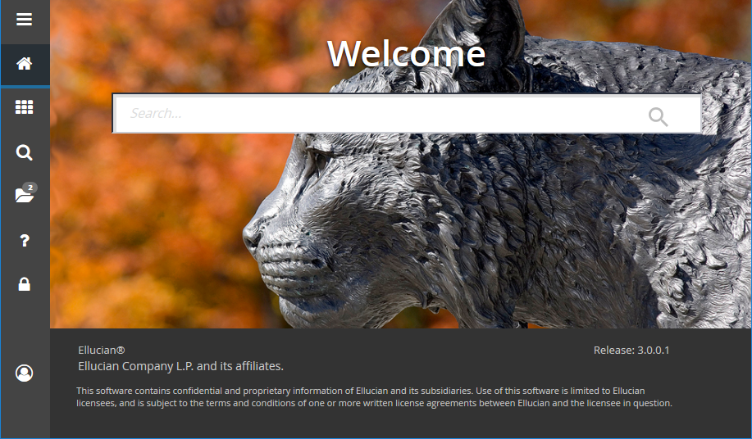

Search box: In the center of the page: enter either the descriptive name of the page or the Banner acronym for the page. Find the desired entry and click Enter. Works with forms, pages, jobs, menus, and quickflows.

Application Navigator / AppNav
The Application Navigator is at the left of every Banner web page.
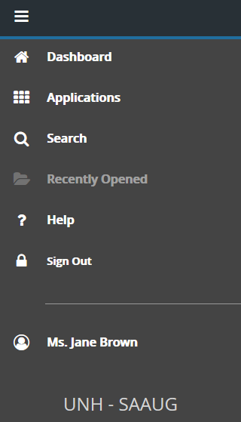
- Menu icon: Click to toggle open the Application Navigator. Shortcut: [Ctrl-M]
- Home icon / Dashboard: This will take you back to the Landing Page. It doesn’t close your open window.
- Magnifying glass icon / Search: Click on this icon to open the Search window. You can then enter either the descriptive name of the page or the Banner acronym. Shortcut: [Ctrl-Shift-Y]
- Folder icon / Recently Opened icon: It is displayed with a count of pages you have visited. Open the list and select a page to access it. Shortcut: [Ctrl-Y]
- ? icon / Help: Click the ? icon to access the online help pages. If it’s greyed out, then it is not available yet for the current page. Shortcut: [Ctrl-Shift-L]
- Sign Out: Use the Sign Out button to make sure you are logged out of the application. Shortcut: [Ctrl-Shift-F]
- Ms. Jane Brown: The Banner user that is signed in.
- UNH – SAAUG:

Forms Are Now Pages, Blocks are now Sections

Page Header
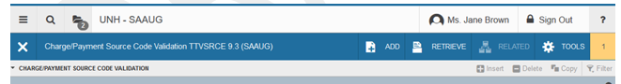
1 2 3 3 4 5 6
- X: Page close icon
- Page Title: In this example it’s Charge/Payment Source Code Validation TTVSRCE9.3 (SAAUG).
- Add and Retrieve Icons: Used to add and retrieve documents.
Shortcut to Add documents: [Alt-A]; shortcut to Retrieve documents: [Alt-R]
- Related Menu: Displays a list of pages that can be accessed from this page.
- Tools Menu: Includes Refresh, Export, Print, Clear Record, Clear Data, Item Properties, Display ID Image, Exit Quickflow, and About Banner. Will also include other options controlled by the page, such as Banner Document Management.
- Notification Center: If there are messages for the page, this block will appear. The number of notifications will be listed. You can toggle them off and on. See Section 3 – System Messaging for more information.

Key Block (enabled view)
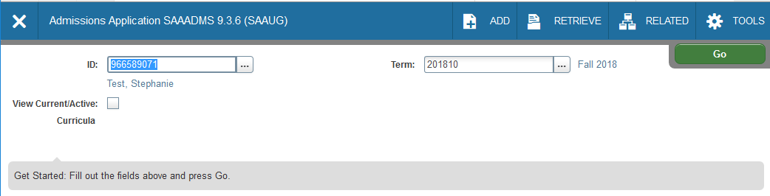
1
2
- Enabled Key Block: The first block on most pages contains key information. When it’s enabled, you can search for key data.
- Go button: Moves you out of the Key Block. Shortcut: [Alt-Page Down]

Key Block (disabled view)
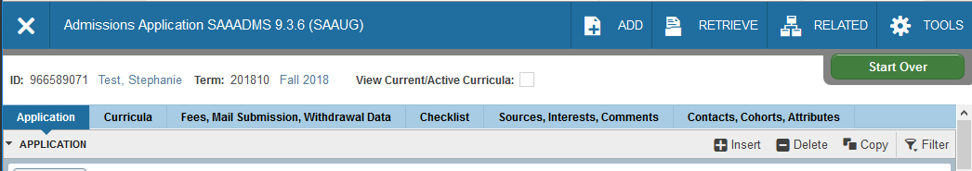
- Disabled Key Block: The first block on most pages contains key information. When a search has been performed, it shows you the key data for the record(s) you’re working on and the fields are disabled.
- Start Over button: Rolls back any un-saved changes and returns to the Key Block for another search.
1
2

Section Header
  - Arrow + Section Name: Click the arrow or section name to collapse and expand the section
  - Insert: Insert Record
  - Delete: Delete Record
  - Copy: Copy Record
  - Filter: OK or double click to return; show GRID Sorting

SDE (Supplemental Data Engine) is now shown as “More Information” in the Section Header
If there is SDE, the “More Information” button is between the Copy and Filter buttons.

If the row doesn’t have more information, the icon will look like a blank page.
If the row has more information, the icon will look like a page of data.

System Messaging
The Notification Center is located to the right of the Tools menu and displays the following types of information as needed:
Success Messages – Green | Error Messages – Red  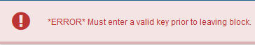
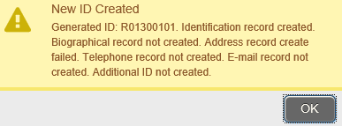  Warning Messages – Yellow | Informational Messages – Blue  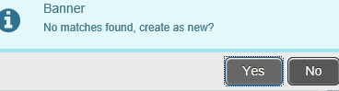

To hide the notification message, click the yellow square to hide the message. Click it again to display the message again. NOTE: These messages will cover the “Go” and “Start Over” buttons, so you will need to hide them to use the buttons.

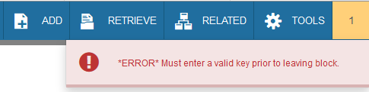

Familiar Concepts in Sections

Save has moved to the bottom right.
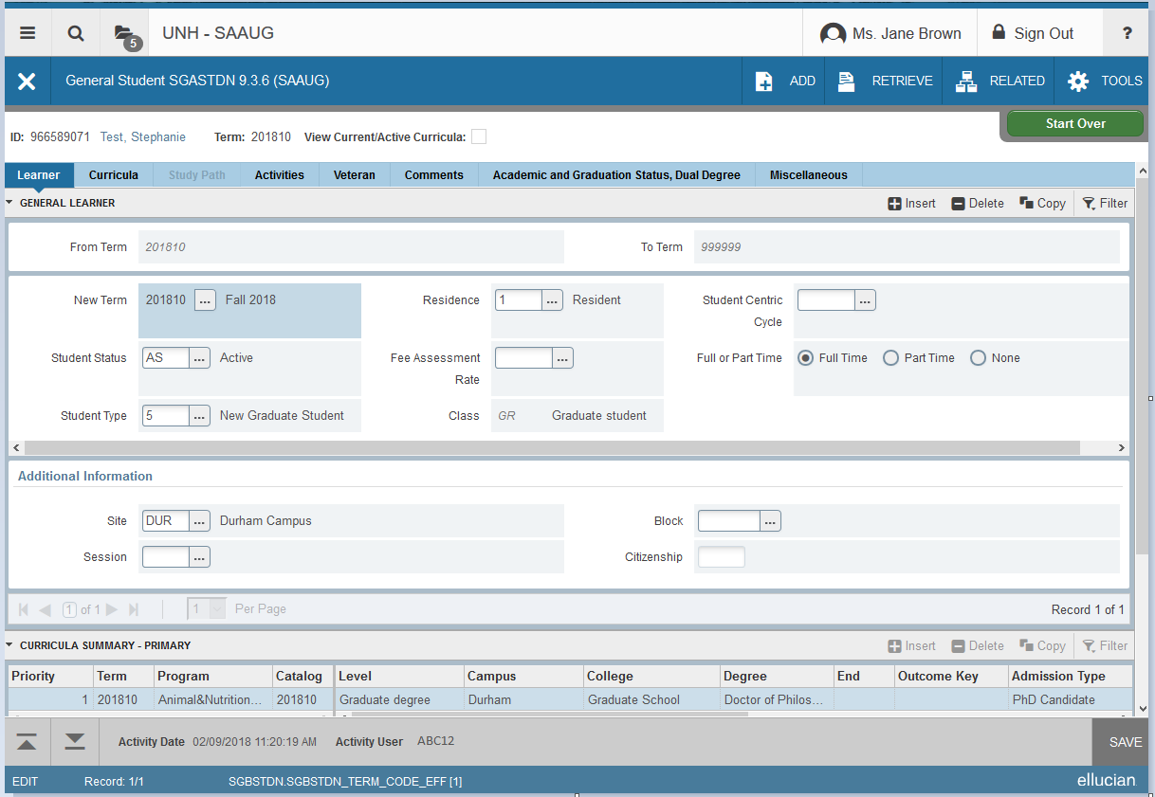
1
3
- Previous Section / Next Section: Arrows at the bottom move between sections. Shortcut to move up: [Alt-Page Up]; to move down: [Alt-Page Down].
- Record Count: The record count for the page.
- Save Button: Commits changes. Shortcut: [F10].
2

Look-up Button
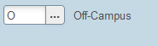
The Lookup button next to a field indicates that the field has the Lookup feature. Click the Lookup button, enter a filter value, and press Enter to display results that match the filter criteria. Then, select a value and click OK, or double-click a value to return the value to the calling page.

Pagination Controls
Data can be viewed one record at a time or in a grid. When viewing one record at a time, you can page through the records using the pagination controls (first, last, next, previous, or specific page number). You can also choose the number of rows Per Page using the drop-down. Please note: go to STVMAJR or TGACSPV to view a sample of pagination controls.

Imaging Controls (Xtender)
For more information on how to use Xtender in Banner 9, contact the Document Management team.
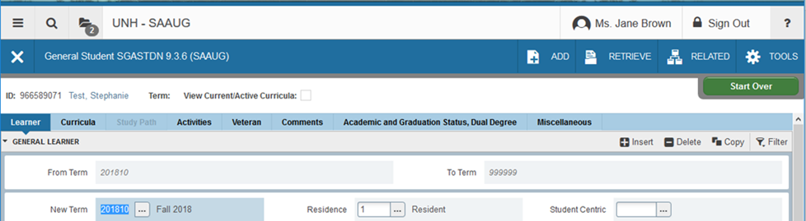
1
2
- Add button: Uploads to imaging. Shortcut: [Alt-A].
- Retrieve button: Displays the corresponding imaging documents. Shortcut: [Alt-R].

Filter Option / Searching
If the Filter button is not greyed-out, you can filter the data in a grid. Click the Filter button to choose the fields to filter on (or click F7). This will bring up the “Basic Filter” form.
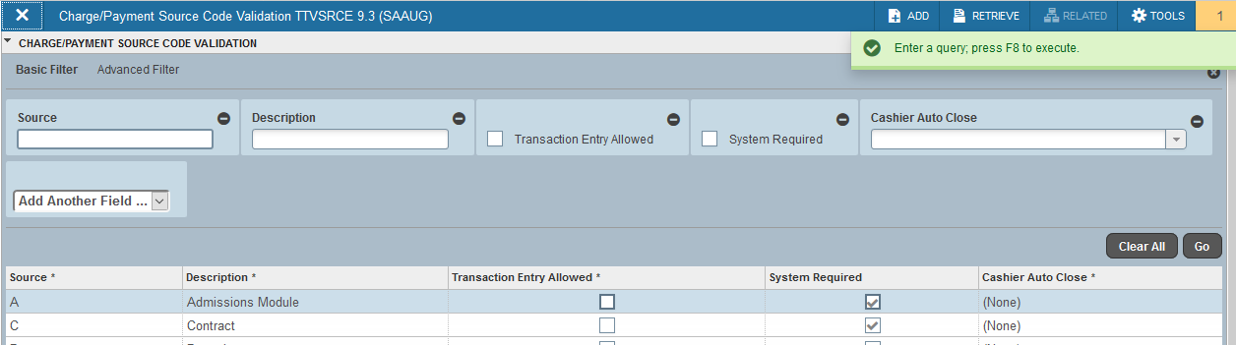

Enter a value in the fields you wish to filter on, then choose Go or click F8 to execute the query. To cancel the query, click the X under the Filter button.

Advanced Filter
If you find the query is slow or want more options, choose “Advanced Filter”. You can improve slow queries by always using “Equals” or “Starts With”.
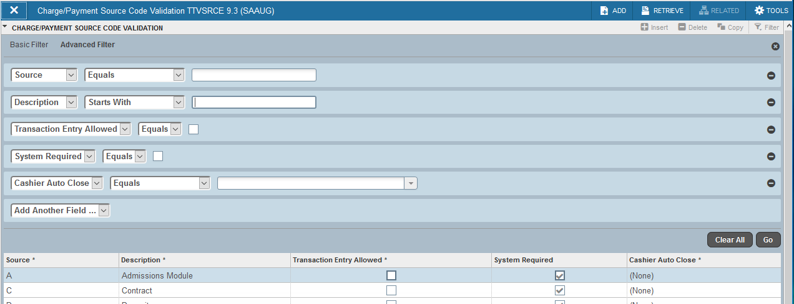

Job Submission
GJAPCTL is still the job submissions form. You can view up to 50 parameter values at one time by choosing the number per page via the drop-down. You still need to move into the Submission section to Save the form.

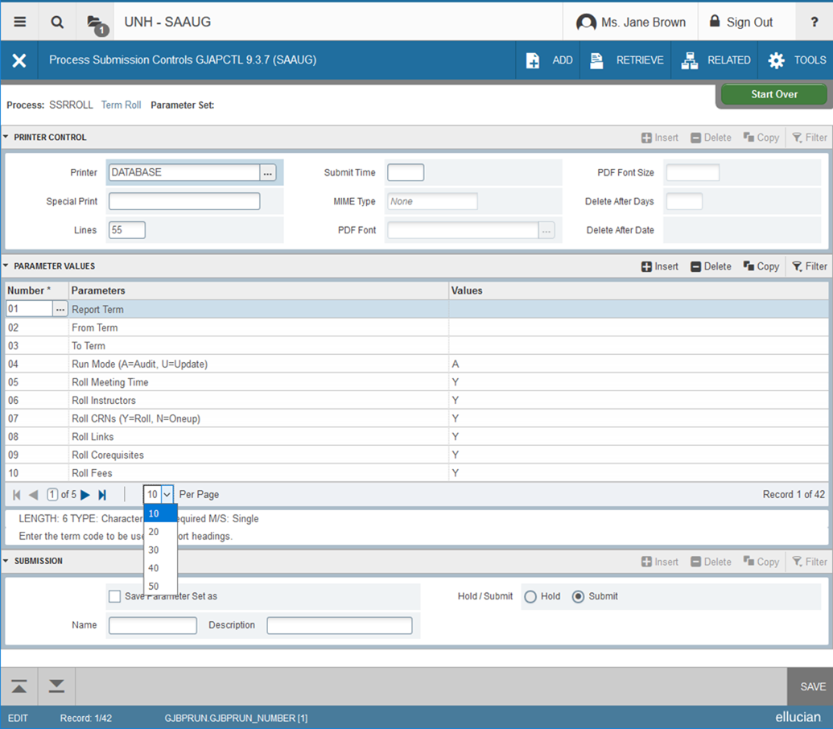
Section Control arrows: The arrows can collapse and expand sections.

Records “Per Page” Drop-down: Choose from the drop-down to have more records displayed per page.

Related Menu
Related Menu: Displays a list of pages that can be accessed from this page.

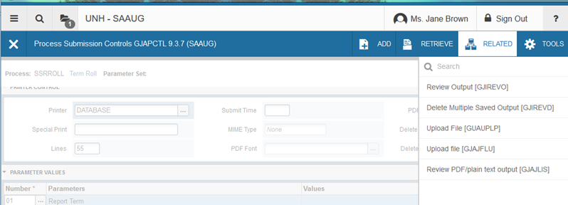

Sorting
You may sort column by clicking on the column header.
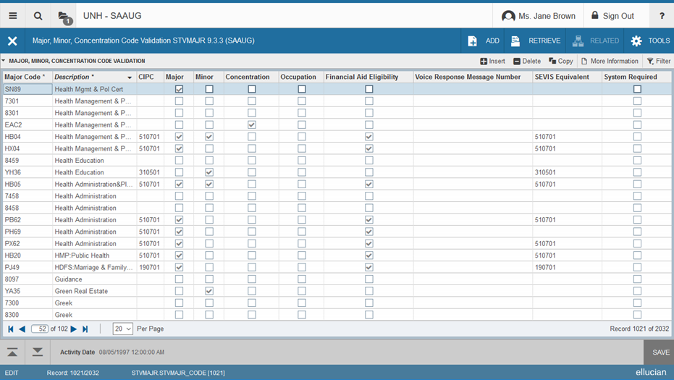

Quickflows
You can access a quickflow by entering the name in any search box or by going to the form: GUAQFLW. To exit a quickflow, choose the “Exit Quickflow” option from the Tools Menu.
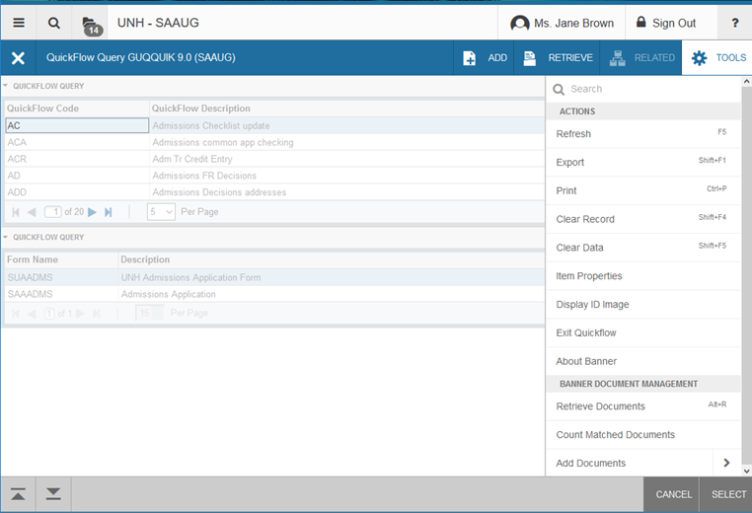

Data Extract
This is a feature from Banner INB that carries over into Banner 9. This feature is available on most forms to pull data into a file. Once you have the data displayed on the form, click Export under TOOLS, you can either Open or SAVE. Please be sure to use a secure data storage application such as Box.
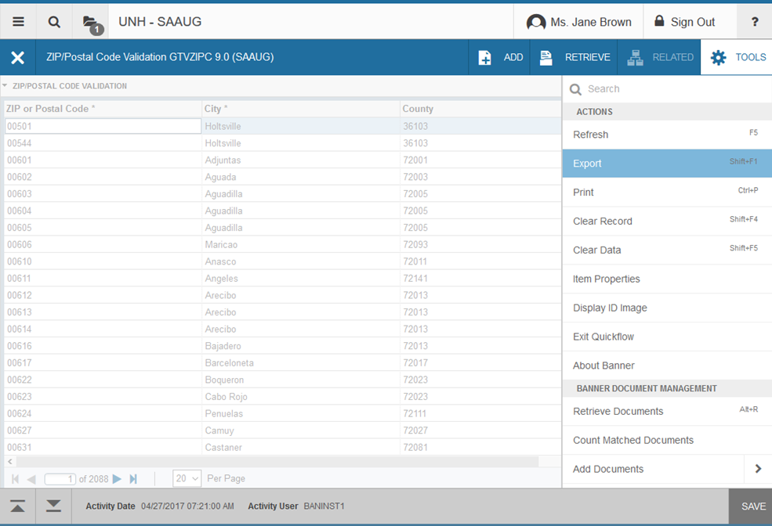

More Information

Other Banner 9 Help Sources:
- Banner 9 help is built into every Page (form).
- Banner 9 UI video – very similar to this document, but in a video
http://edservices.elluciancloud.com/delivery/PublicOnDemand/B9QuickTour/bgen-B9-quick-tour.mp4
- Banner Keyboard Shortcuts
https://banner9guide.ellucian.com/sites/default/files/banner_keyboard_shortcuts.pdf
Or, See Appendix D: Windows Shortcuts and Appendix E: Mac Shortcuts

Terminology Changes
Banner 8 | Banner 9
Forms | Pages
From Key Block to Next Block | Go
Blocks | Sections
Rollback | Start Over
Page Down & Page Up | 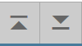  Previous Section & Next Section
Query | Filter

Appendix A: Windows Keyboard Shortcuts
Banner 9 Function | Banner 9 Shortcut | Banner 8 Function | Banner 8 Shortcut
Application Navigator Display Open Items | CTRL + Y
Application Navigator Search | CRTL + Shift + Y
Application Navigator Help | CTRL + Shift + L | Help | Ctrl + H
Application Navigator Sign Out | CTRL + Shift + F
Display the Menu | CTRL + M
Open Main Menu | CTRL + Alt + M
Open Related Menu | Alt + Shift + R
Open Tools Menu | Alt + Shift + T
Choose/Submit/Action | Return/Enter | Direct Access Box | Return/Enter
Next Section | ALT + Page Down | Next Block | Ctrl + Page Down
Previous Section | ALT + Page Up | Previous Block | Ctrl + Page Up
Cancel form, Exit,  Close Current Page,  Cancel Search or Query | Ctrl + Q | Exit,  Cancel Query,  Close Form | Ctrl + Q
Cancel Action | Esc
Next Field/Item | Tab | Next Field | Tab
Page Tab 1,  Page Tab 2,  Page Tab 3, … | CTRL + Shift + 1, CTRL + Shift + 2, CTRL + Shift + 3, etc…
Previous Field/Item | Shift + Tab | Previous Field | Shift + Tab
Export | SHIFT + F1
Duplicate Item | F3 | Duplicate Item | F3
Duplicate Selected Record | F4 | Duplicate Record | F4
Clear One Record | Shift + F4 | Clear Record | Shift + F4
Clear Page/Start Over/Refresh/Rollback | F5 | Rollback | F7
Clear All in Section | Shift + F5
Insert/Create Record | F6 | Insert Record | F6
Delete Record | Shift + F6 | Delete Record | Shift + F6
Search/Open Filter Query | F7 | Enter Query | F7
Execute Filter Query | F8 | Execute Query | F8
Banner 9 Function | Banner 9 Shortcut | Banner 8 Function | Banner 8 Shortcut
List of Values | F9 | List of Values | F9
Save | F10 | Save | F10
Print | CTRL + P | Print | Shift + F8
Up | Up Arrow | Previous line/row | Up Arrow
Down | Down Arrow | Next line/row | Down Arrow
Previous Page Up | Page Up | Scroll Up | Page-up
Next Page Down | Page Down | Scroll Down | Page-down
First Page | CTRL + Home
Last Page | CTRL + End
Edit | CTRL + E | Edit | Ctrl + E
Copy | CTRL + C | Copy | Ctrl + C
Cut | CTRL + X | Cut | Ctrl + X
Paste | CTRL + V | Paste | Ctrl + V
Undo | CTRL + Z
Redo | CTRL + Shift + Z
Select on a Called Page | ALT + S
More Information | CTRL + Shift + U
Retrieve BDM Documents | ALT + R
Add BDM Documents | ALT + A
Submit Work Flow | ALT + W
Release Work Flow | ALT + Q
Checkbox Autofill | Space bar | Checkbox auto fill | Space Bar
Today’s Date Autofill | Any letter key, Enter | Today’s Date autofill | Any letter key, Enter

Appendix B: Mac Keyboard Shortcuts
Banner 9 Function | Banner 9 Shortcut | Banner 8 Function | Banner 8 Shortcut
Application Navigator Display Open Items | CTRL + Y
Application Navigator Search | CRTL + Shift + Y
Application Navigator Help | CTRL + Shift + L | Help | Ctrl + H
Application Navigator Sign Out | CTRL + Shift + F
Opens the Main Menu | CTRL + M
Closes Main Menu | Ctrl + Alt + M
Open Related Menu | Alt + Shift + R
Open Tools Menu | Alt + Shift + T
GO Button /Choose / Submit/Action | Return/Enter
Next Section | ALT + Page Down | Next Block | Ctrl + Page Down
Previous Section | ALT + Page Up | Previous Block | Ctrl + Page Up
Cancel form, Exit,  Close Current Page,  Cancel Search or Query | Ctrl + Q | Exit, Cancel Query, Close Form | Ctrl + Q
Cancel Action | Esc
Next Field/Item | Tab | Next Field | Tab
Page Tab 1,  Page Tab 2,  Page Tab 3, … | CTRL + Shift + 1, CTRL +Shift + 2, CTRL + Shift + 3, etc… | Forward through tabs | Ctrl + Tab
Previous Field/Item | Shift + Tab | Previous Field | Shift + Tab
Export | Shift + fn + F1
Duplicate Item | fn + F3 | Duplicate Item | fn + F3
Duplicate Selected Record | fn + F4 | Duplicate Record | fn + F4
Clear Page, Start Over, Refresh, Rollback | F5 | Rollback | Shift + fn + F7
Clear All in Section | Shift + F5
Insert/Create Record | F6 | Insert Record | F6
Delete Record | Shift + F6 | Delete Record | Shift + F6
Search/Open Filter Query | fn + F7 | Enter Query | fn + F7
Execute Filter Query | fn + F8 | Execute Query | fn + F8
List of Values | fn + F9 | List of Values | fn + F9
Banner 9 Function | Banner 9 Shortcut | Banner 8 Function | Banner 8 Shortcut
Save | fn + F10 | Save | fn + F10
Print | CTRL + P | Print | Shift + fn + F8
Up | Up Arrow | Previous Record/row | Up Arrow
Previous Page Up | Page Up | Scroll Up | Page-up
Next Page Down | Page Down | Scroll Down | Page-down
First Page | CTRL + Home
Last Page | CTRL + End
Edit | CTRL + E | Edit | Ctrl + E
Copy | fn + F4 | Copy | CTRL + C
Cut | CTRL + X | Cut | Ctrl + X
Paste | CTRL + V | Paste | Ctrl + V
Undo | Ctrl + Z
Redo | CTRL + Shift + Z
Select on a Called Page | ALT + S
More Information | CTRL + Shift + U
Retrieve BDM Documents | ALT + R
Add BDM Documents | ALT + A
Submit Work Flow | ALT + W
Release Work Flow | ALT + Q
Checkbox Autofill | Space bar | Checkbox Autofill | Space bar
Today’s Date Autofill | Any letter key, Return | Today’s Date Autofill | Any letter key, Return

