Banner 9 Student Quick Tips
These address the most common issues that have been reported. Please be sure you are following these tips & tricks to have the best experience.
- Make sure you are not using a bookmark to get to Banner 9. Be sure to use an official link: the USNH Gateway page -- http://usnhgateway.org/ or the UNH Portal my.unh.edu
- After using a Page, close it
- Do not use your browser’s Forward and Back buttons to get around
- Always logout of Banner when you’re done, prior to closing your browser.
- Banner 9 is a browser-based application. As such, sometimes things can happen with the browser itself. If you’ve followed tips 1-5 and are still having issues, you may need to logout of Banner 9, clear the cache, and close the browser.
- We are continuing to work to improve performance. If you are a fast typist, Banner may not be able to keep up with your keystrokes; if you experience that issue, you may just need to type a bit more slowly. Performance with searches and filtering is greatly improved if you use the conditions “Equals” or “Starts With”. **

Banner 9 Student FAQ (Frequently Asked Questions)

When will the Banner 9 production environment be open to everyone?
Banner 9 Student is available to everyone now and has been since August 6th.

When is Banner 8 going away?
At the close of business on Wednesday, October 31.

What browsers work with Banner 9?
Any modern browsers—this includes Firefox, Chrome, Safari, and Edge. Chrome is the recommended browser. Internet Explorer does work but may be slower and have more errors.
Note for Xtender users: Xtender users who need to scan, annotate, or print documents will need to continue using Internet Explorer. If this causes significant difficulty for your office, please contact the Document Management Group to discuss possible options. **

Is Banner 9 Mac compatible?
Yes.

How do I get to Banner 9?
The link is available on the USNH Gateway page -- http://usnhgateway.org/ and it is also available at my.unh.edu. DO NOT bookmark the link or you will get errors. Don’t login to Banner 9 until you are ready to use a Page (formerly known as a Form).

What is my Banner 9 password?
Your Banner 9 password is the same as your UNH/GSC password. This may be different than your Banner 8 password.

How do I change my Banner 9 password?
Your Banner 9 password is the same as your UNH/GSC password. You no longer need to update your Banner 9 password separately.

Do you need to be logged into the VPN to use Banner 9?
Yes.

Will the functionality in Banner 9 be the same as in Banner 8?
Yes.

Will all the forms that I use in Banner 8 still be in Banner 9?
Yes.

How do I get to the actual form, instead of just the ID field?
In Banner 8, you could use Ctrl-PgDn or Block->Next to get the student’s information. In Banner 9, you can use Alt-PgDn or the green “Go” button.
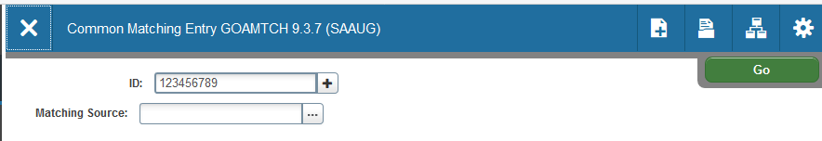

What do I do if I get a “Message from Banner Document Management…”?
If you don’t know what Banner Document Management is and you get the message “Message from Document Management… Banner Document Management is installed at your site, but you are not set up as a user in that system. Please contact your Administrator for information.” you have probably clicked one of the Xtender icons instead of using the “Go” button or Alt-PgDn.
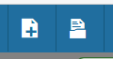
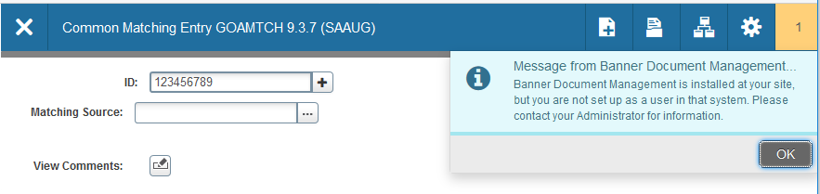
These two icons (Add Documents and Retrieve Documents) are only used to access Xtender documents. If you don’t know what that is, you can feel free to ignore them.
Sometimes the Go button may be hidden by the message center. These are the same messages that used to appear in the bottom message bar in Banner 8. To hide the message, if there is a button on the message, click it. Otherwise, click on the yellow block with the number in it.

What do I do if I get an "invalid username/password; logon denied" message?
This error happens when you use a bookmark, which is not recommended. To avoid this error, use one of the official links: USNH Gateway page -- http://usnhgateway.org/ or the UNH Portal my.unh.edu. If you get this message, click “OK”. You will then get a message “Return to Home page”, click “RETURN HOME” and you will back at the Landing Page.

What do I do if I get an "Invalid username or Password" message when logging in?
This error happens when you login with the wrong password or username. Banner 9 uses the UNH/GSC login. It is no longer a separate password. Please contact the Service Desk if you need password help.

What do I do if I see “Workspace Services”?
If you were not prompted to login and you get the “Workspace Services” message, then just click the Home icon on the left. That will bring you back to the Banner 9 landing page. This is most often seen in Internet Explorer.

Why does a student ID that I worked on earlier today keep popping up? Or, how do I ensure that when I move from form to form the student I am working with remains unchanged?
The best way to ensure you are working with the correct student is to close out of a form before bringing up a new form. This issue commonly happens when users move from form to form using the “Recently Opened” links, the “Applications” menu, or the left-menu Search, without closing out of their current form.
One way to describe what is happening is to imagine several pieces of paper stacked one on top of each other on your desk. Each piece of paper contains information about a different student. When you continue to open forms in Banner without closing the previous form, you are stacking forms on top of each other – just like the stack of paper on your desk. Closing a form is like removing it from the stack of papers. If you have an open form, that will become the student you are now working with, even if you haven’t used that form in hours or don’t even notice the form.

Can you still search on name?
Yes. However, we recommend that you use the comparison operator of "Equals" or "Starts With" to make the search faster.

Can you create a favorites list/menu?
Yes. Use My Banner. If you had My Banner setup in Banner 8, it will still be available in Banner 9. You can find it in the left-side menu, under “Applications”. It is still called My Banner. It will not appear under “Applications” unless you have set it up.

How do you do an insert?
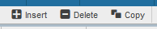
Any table that allows an insert will have the + Insert button at the top right. Click the button to insert a row.

How do you do a delete or “Record Remove”?
Any table that allows an insert will have the - Delete button at the top right. Click the button to delete a row.

How do I print in Banner 9?
Go to Tools -> Print or type Ctrl-p. Some have found it easier to use screen capture tools.

Can you have multiple Banner 9 sessions open at the same time?
Yes. We recommend loading a Page right away whenever you start Banner 9.

On the SSASECQ page, can the Enrollment numbers be in the row with the course?
This is a baseline page and the Enrollment numbers for the highlighted row now appear in the section below.

What are the shortcut keys?
Please refer to the Banner 9 - Quick Reference documentation, which can be found in the “Useful Links & Documents” section at the bottom of the project web page.

What should I do if I get the “Workspace Services” message?
You should be able to click the browser’s Back button to get back into Banner (depending on the browser, it may take 2-3 Back clicks). You should only use the Back button in Banner 9 in a case like this where you have an error.

Is the Export functionality going to be available on admin pages in Banner 9?
We are reviewing this functionality for future use.

How can I see the bottom row in the popup list? **
When choosing from a popup list for a field, the bottom row may be hidden by a bottom scrollbar. This happens when either the browser window has been zoomed in or out, or when the monitor’s display has been scaled to something besides 100%.
The workaround is to zoom the browser until the hidden row can be seen. If the monitor’s display setting is the issue, that may need to be changed as well. Another possible workaround is to change the pagination on the popup list to a smaller number of rows per page. This will remove the bottom scrollbar on some popup lists.

Can we get a copy of the PowerPoint presentation?
Yes. There is a link to the most up-to-date version on the project web page.

** Items marked with two red stars are items that UNH IT or the vendor are researching.

